CLI Command

1. Configure all device based on table configuration, dont forget rename all router according to their location!

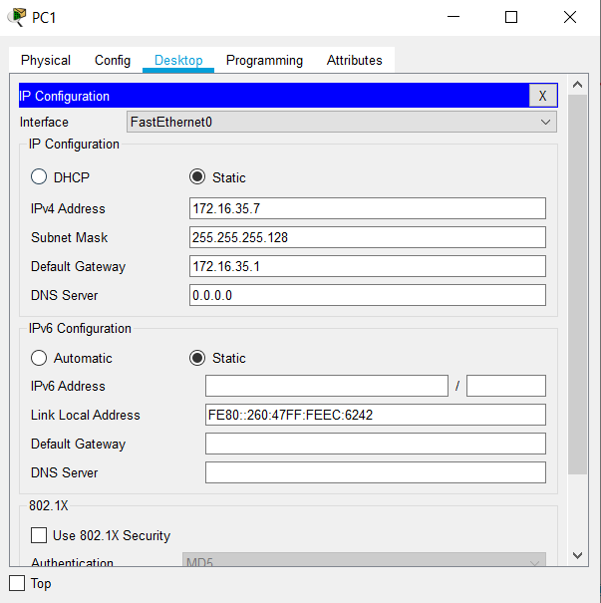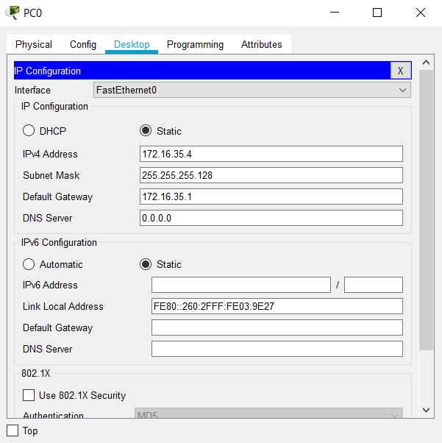**- PC0 – PC09**

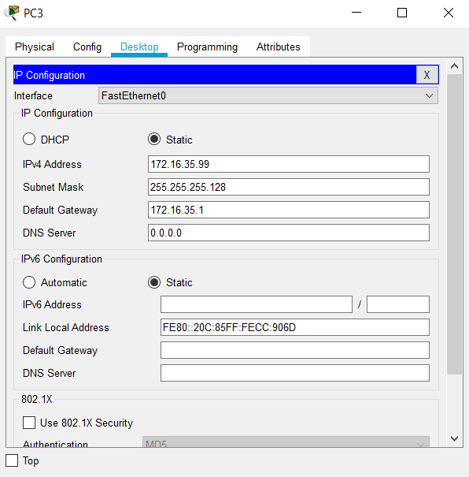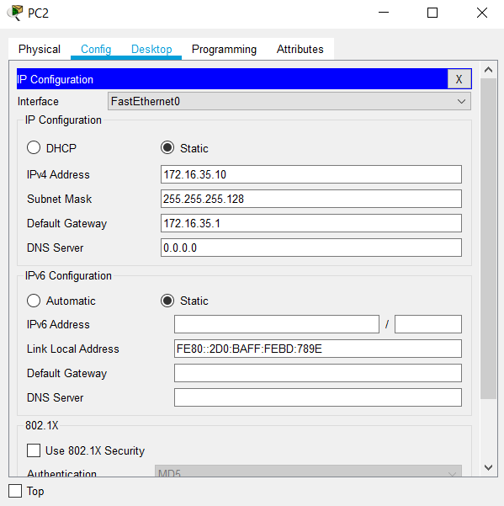

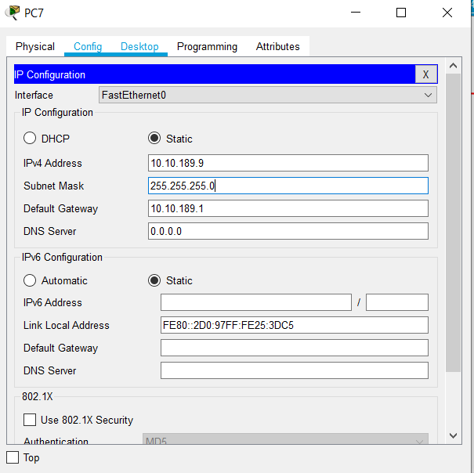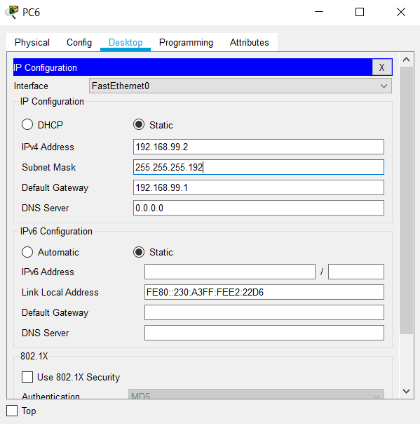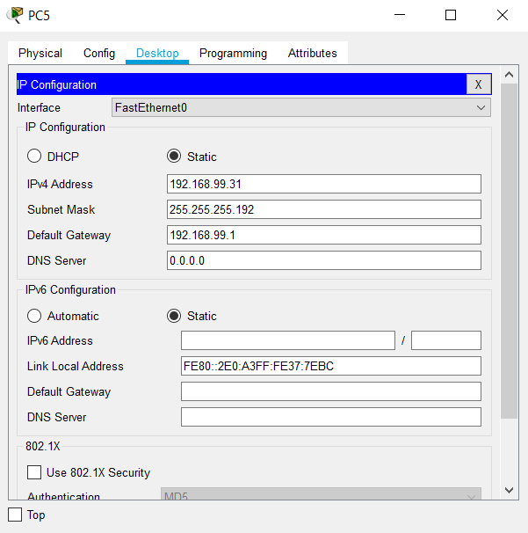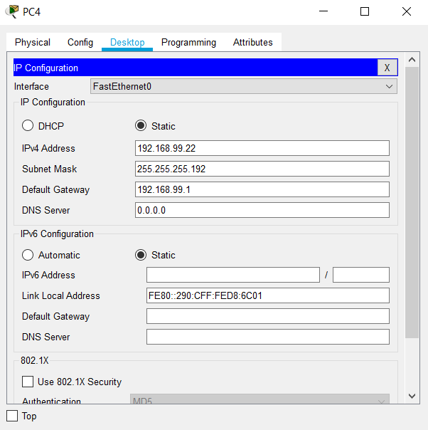

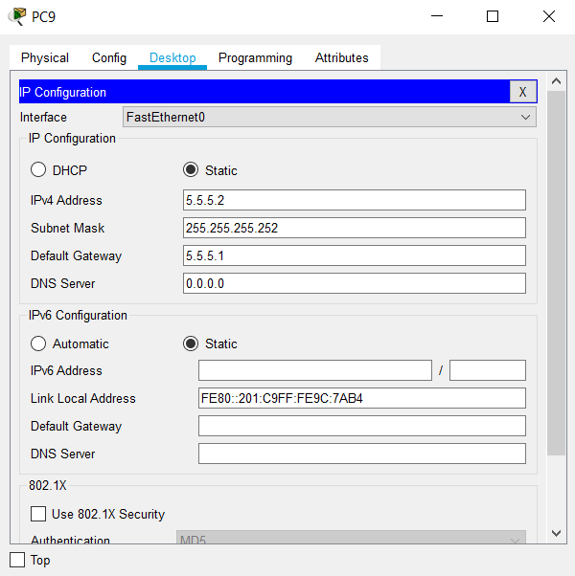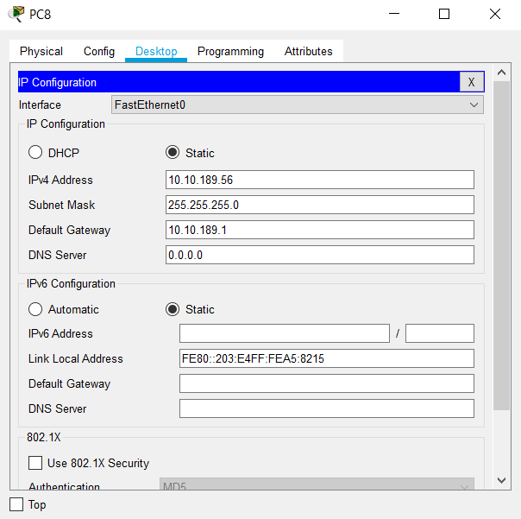

**- CLI Command RouterBinusKemanggisan**

Router>enable

Router#configure terminal

Router (config) #interface fa0/0

Router (config-if) #ip address 172.16.35.1 255.255.255.128

Router (config-if) #no shutdown

Router (config-if) #exit

Router (config) #interface Serial2/0

Router (config-if) #ip address 102.14.239.7 255.255.255.240

Router (config-if) #no shutdown

**- CLI Command RouterBinusMalang**

Router>enable

Router#configure terminal

Router (config) #interface fa0/0

Router (config-if) #ip address 192.168.99.1 255.255.255.192

Router (config-if) #no shutdown

Router (config-if) #exit

Router (config) #interface Serial2/0

Router (config-if) #ip address 102.14.239.10 255.255.255.240

Router (config-if) #no shutdown

Router (config-if) #exit

Router (config) #interface Serial3/0

Router (config-if) #ip address 139.86.54.3 255.255.255.248

Router (config-if) #no shutdown

**- CLI Command RouterBinusBandung**

Router>enable

Router#configure terminal

Router (config) #interface fa0/0

Router (config-if) #ip address 10.10.189.1 255.255.255.0

Router (config-if) #no shutdown

Router (config-if) #exit

Router (config) #interface Serial2/0

Router (config-if) #ip address 139.86.54.2 255.255.255.248

Router (config-if) #no shutdown

Router (config-if) #exit

Router (config) #interface Serial3/0

Router (config-if) #ip address 100.91.67.15 255.255.255.224

Router (config-if) #no shutdown

**- CLI Command RouterBinusAnggrek**

Router>enable

Router#configure terminal

Router (config) #interface fa0/0

Router (config-if) #ip address 5.5.5.1 255.255.255.252

Router (config-if) #no shutdown

Router (config-if) #exit

Router (config) #interface Serial2/0

Router (config-if) #ip address 100.91.67.25 255.255.255.224

Router (config-if) #no shutdown

2. Give nick name on each device with 3 digit your name!

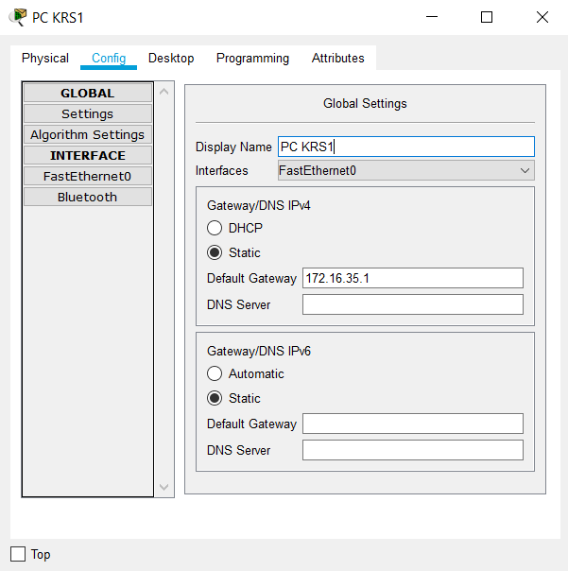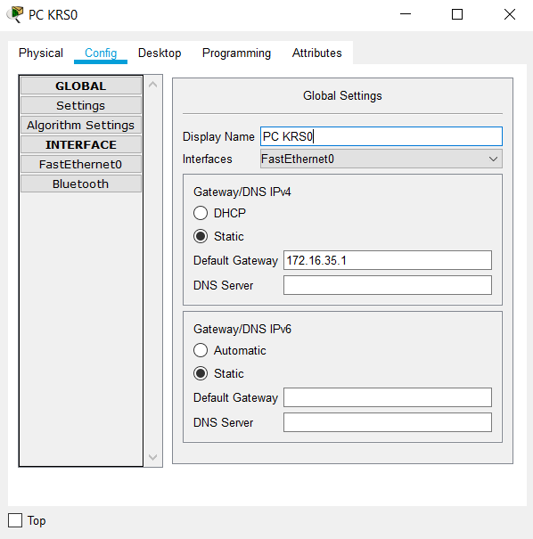**- PC KRS0 – PC KRS9**

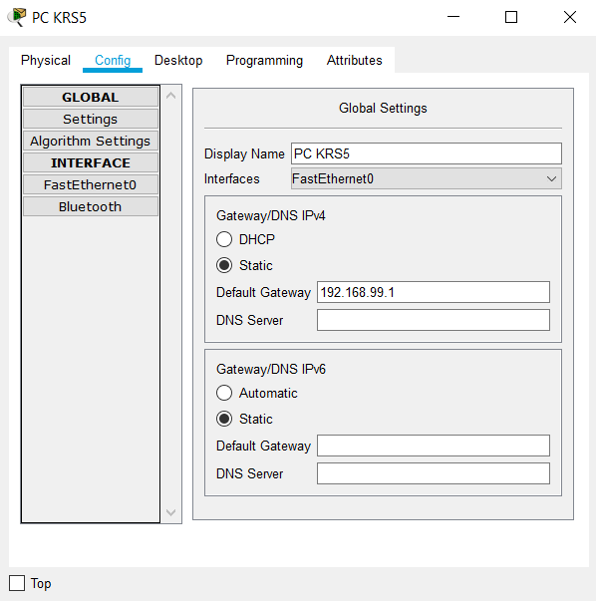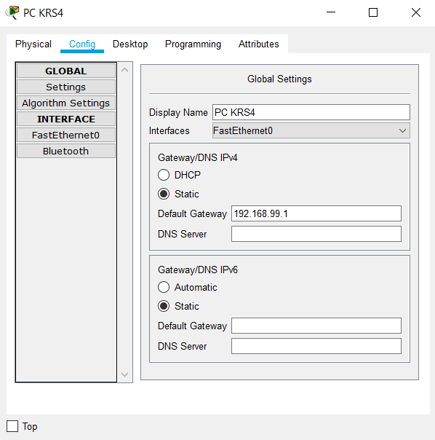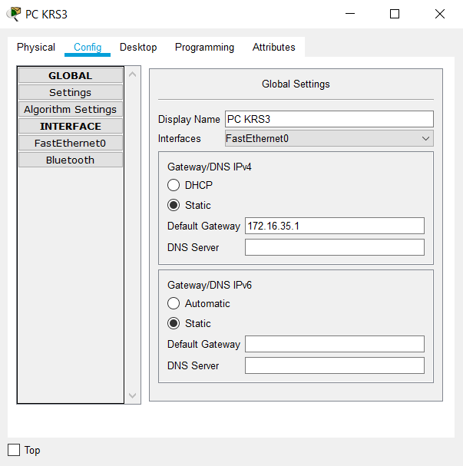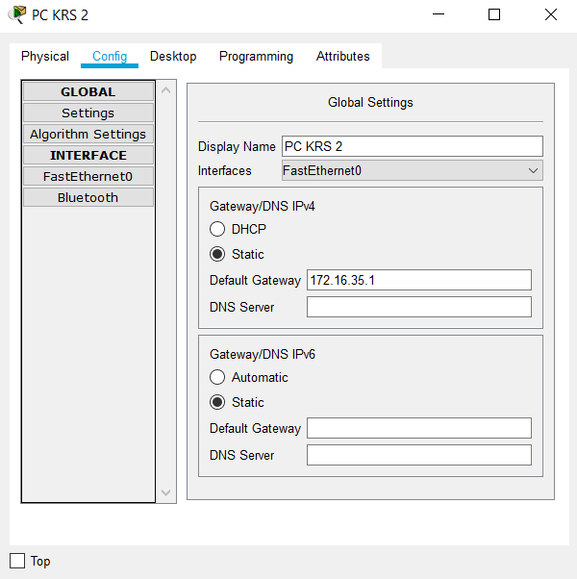

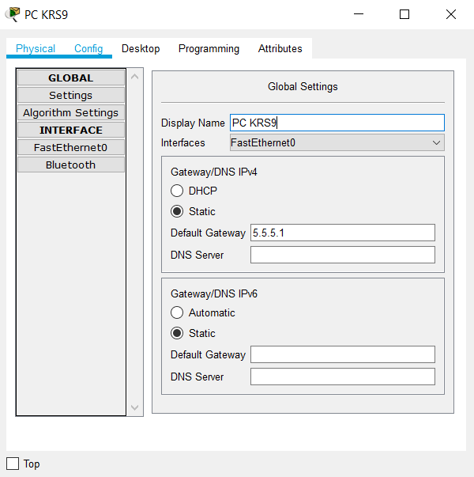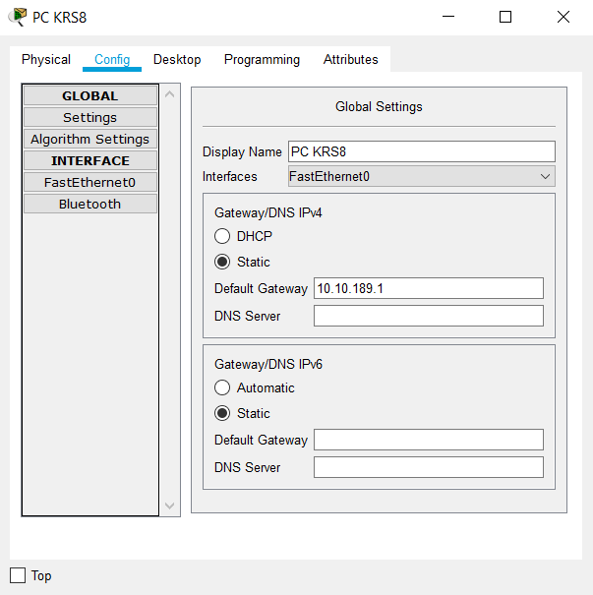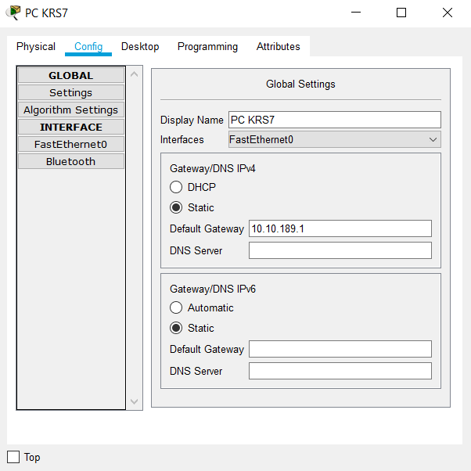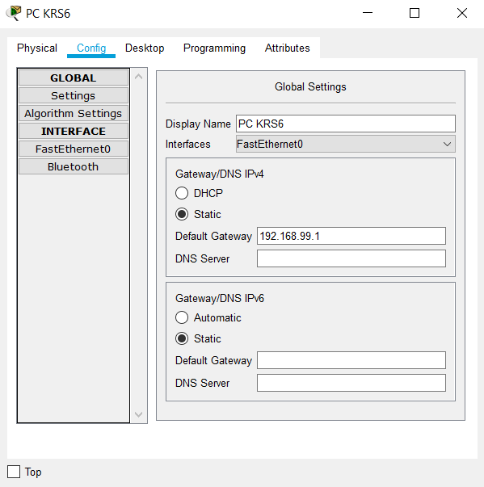

**- SKRS0 – SKRS3**

Switch>enable

Switch#configure terminal

Switch (config) #hostname SKRS0

Switch>enable

Switch#configure terminal

Switch (config) #hostname SKRS1

Switch>enable

Switch#configure terminal

Switch (config) #hostname SKRS2

Switch>enable

Switch#configure terminal

Switch (config) #hostname SKRS3

**- RouterBinusKemanggisan, RouterBinusMalang, RouterBinusBandung, RouterBinusAnggrek**

Router>enable

Router#configure terminal

Router (config) #hostname RKRSBinusKemanggisan

Router>enable

Router#configure terminal

Router (config) #hostname RKRSBinusMalang

Router>enable

Router#configure terminal

Router (config) #hostname RKRSBinusBandung

Router>enable

Router#configure terminal

Router (config) #hostname RKRSBinusAnggrek

3. Configure **ALL** router with static routing to provide routing for all PC !

**- RKRSBinusKemanggisan**

RKRSBinusKemanggisan>enable

RKRSBinusKemanggisan#configure terminal

RKRSBinusKemanggisan (config) #ip route 192.168.99.0 255.255.255.192 102.14.239.10

RKRSBinusKemanggisan (config) #ip route 10.10.189.0 255.255.255.0 102.14.239.10

RKRSBinusKemanggisan (config) #ip route 5.5.5.0 255.255.255.252 102.14.239.10

RKRSBinusKemanggisan (config) #ip route 139.86.54.0 255.255.255.248 102.14.239.10

RKRSBinusKemanggisan (config) #ip route 100.91.67.0 255.255.255.224 139.86.54.2

**- RKRSBinusMalang**

RKRSBinusMalang>enable

RKRSBinusMalang#configure terminal

RKRSBinusMalang (config) #ip route 172.16.35.0 255.255.255.128 102.14.239.7

RKRSBinusMalang (config) #ip route 10.10.189.0 255.255.255.0 139.86.54.2

RKRSBinusMalang (config) #ip route 5.5.5.0 255.255.255.252 139.86.54.2

RKRSBinusMalang (config) #ip route 100.91.67.0 255.255.255.224 139.86.54.2

**- RKRSBinusBandung**

RKRSBinusBandung>enable

RKRSBinusBandung#configure terminal

RKRSBinusBandung (config) #ip route 172.16.35.0 255.255.255.128 139.86.54.3

RKRSBinusBandung (config) #ip route 192.168.99.0 255.255.255.0 139.86.54.3

RKRSBinusBandung (config) #ip route 5.5.5.0 255.255.255.252 100.91.67.25

RKRSBinusBandung (config) #ip route 102.14.239.0 255.255.255.240 139.86.54.3

**- RKRSBinusAnggrek**

RKRSBinusAnggrek>enable

RKRSBinusAnggrek#configure terminal

RKRSBinusAnggrek (config) #ip route 172.16.35.0 255.255.255.128 100.91.67.15

RKRSBinusAnggrek (config) #ip route 192.168.99.0 255.255.255.192 100.91.67.15

RKRSBinusAnggrek (config) #ip route 10.10.189.0 255.255.255.0 100.91.67.15

RKRSBinusAnggrek (config) #ip route 102.14.239.0 255.255.255.240 139.86.54.3

RKRSBinusAnggrek (config) #ip route 139.86.54.0 255.255.255.248 100.91.67.15

4. Verify routing table with print all routing table on each router!

**- RKRSBinusKemanggisan**

RKRSBinusKemanggisan>enable

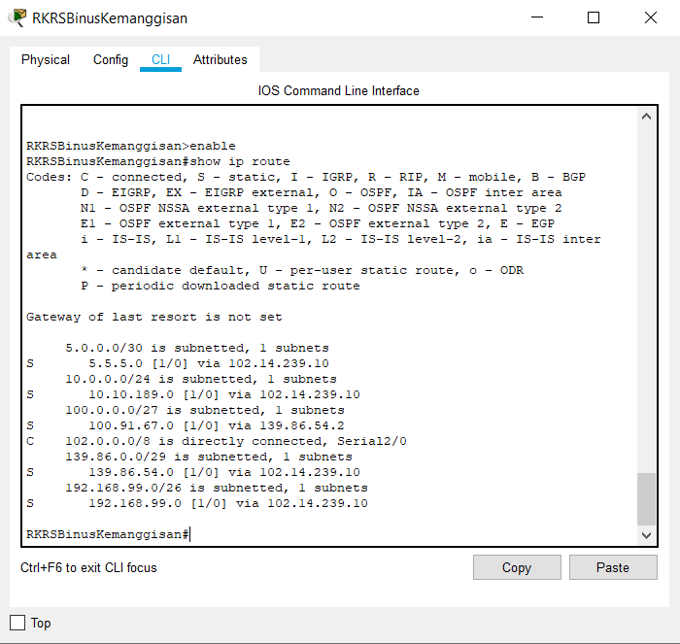RKRSBinusKemanggisan#show ip route

**- RKRSBinusMalang**

RKRSBinusMalang>enable

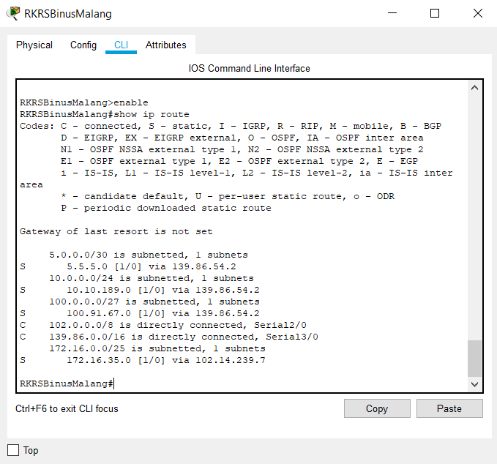RKRSBinusMalang#show ip route

**- RKRSBinusBandung**

RKRSBinusBandung>enable

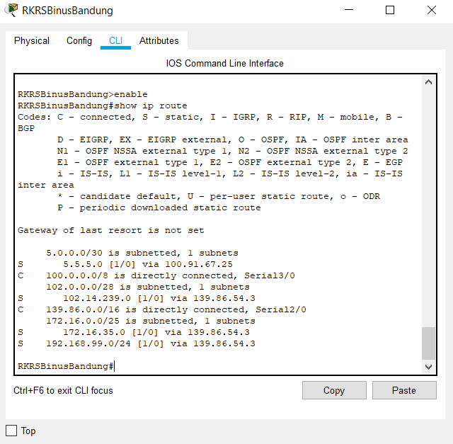RKRSBinusBandung#show ip route

**- RKRSBinusAnggrek**

RKRSBinusAnggrek>enable

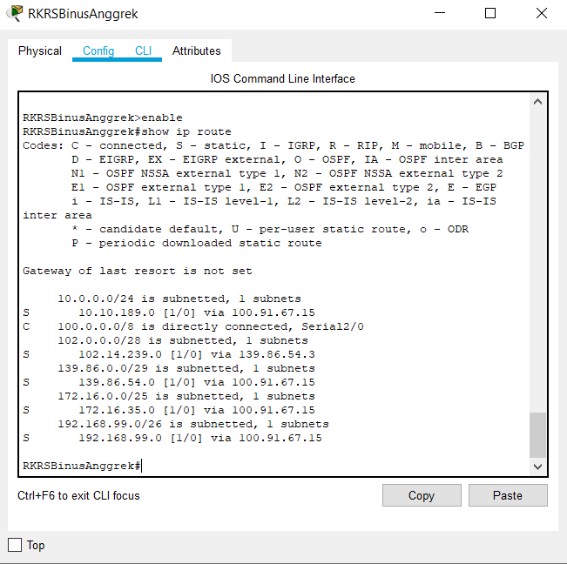RKRSBinusAnggrek#show ip route